

|  |  |  |  |  |  |  |  |  |
| --- | --- | --- | --- | --- | --- | --- | --- | --- |
|  | | | | | | | | |
|  | | Pharmaceutical Store Management | | | | |  | |
|  |  | | | | | | |  |
|  | | | |  |  | | | |
|  | | | | Group Members **Nihar Patel AU1940119 (B. Tech-CSE)**  **Mohit Prajapati AU1940171 (B. Tech-CSE)**  **Rushil Borad AU1940179 (B. Tech-CSE)**  **Course: CSE250 Database Management System**  **Semester: 4** |  | | | |
|  | | | |  |  | | | |
|  | | |  | | |  | | |



**Description:**

This Database Management System is recommended for small or medium sized Pharmaceutical store. Schema includes all the things which are to be used and managed in a Store.

* This Database deals with Service providers as well as Buyers.
* It also stores all the necessary information regarding medicines and general description like content, type, uses, etc.
* A specific system has been allotted to give discount to the customers.
* This Database management system also stores general information regarding store employees.
* Facility like Bill info is also stored in the database.

**Normalization:**

All the tables are made from the view point that none of them have partial function dependency, all tables just one functional dependency hence they are in 2 NF. All are in 3 NF as there are no transitive functional dependencies.

**ER Diagram**

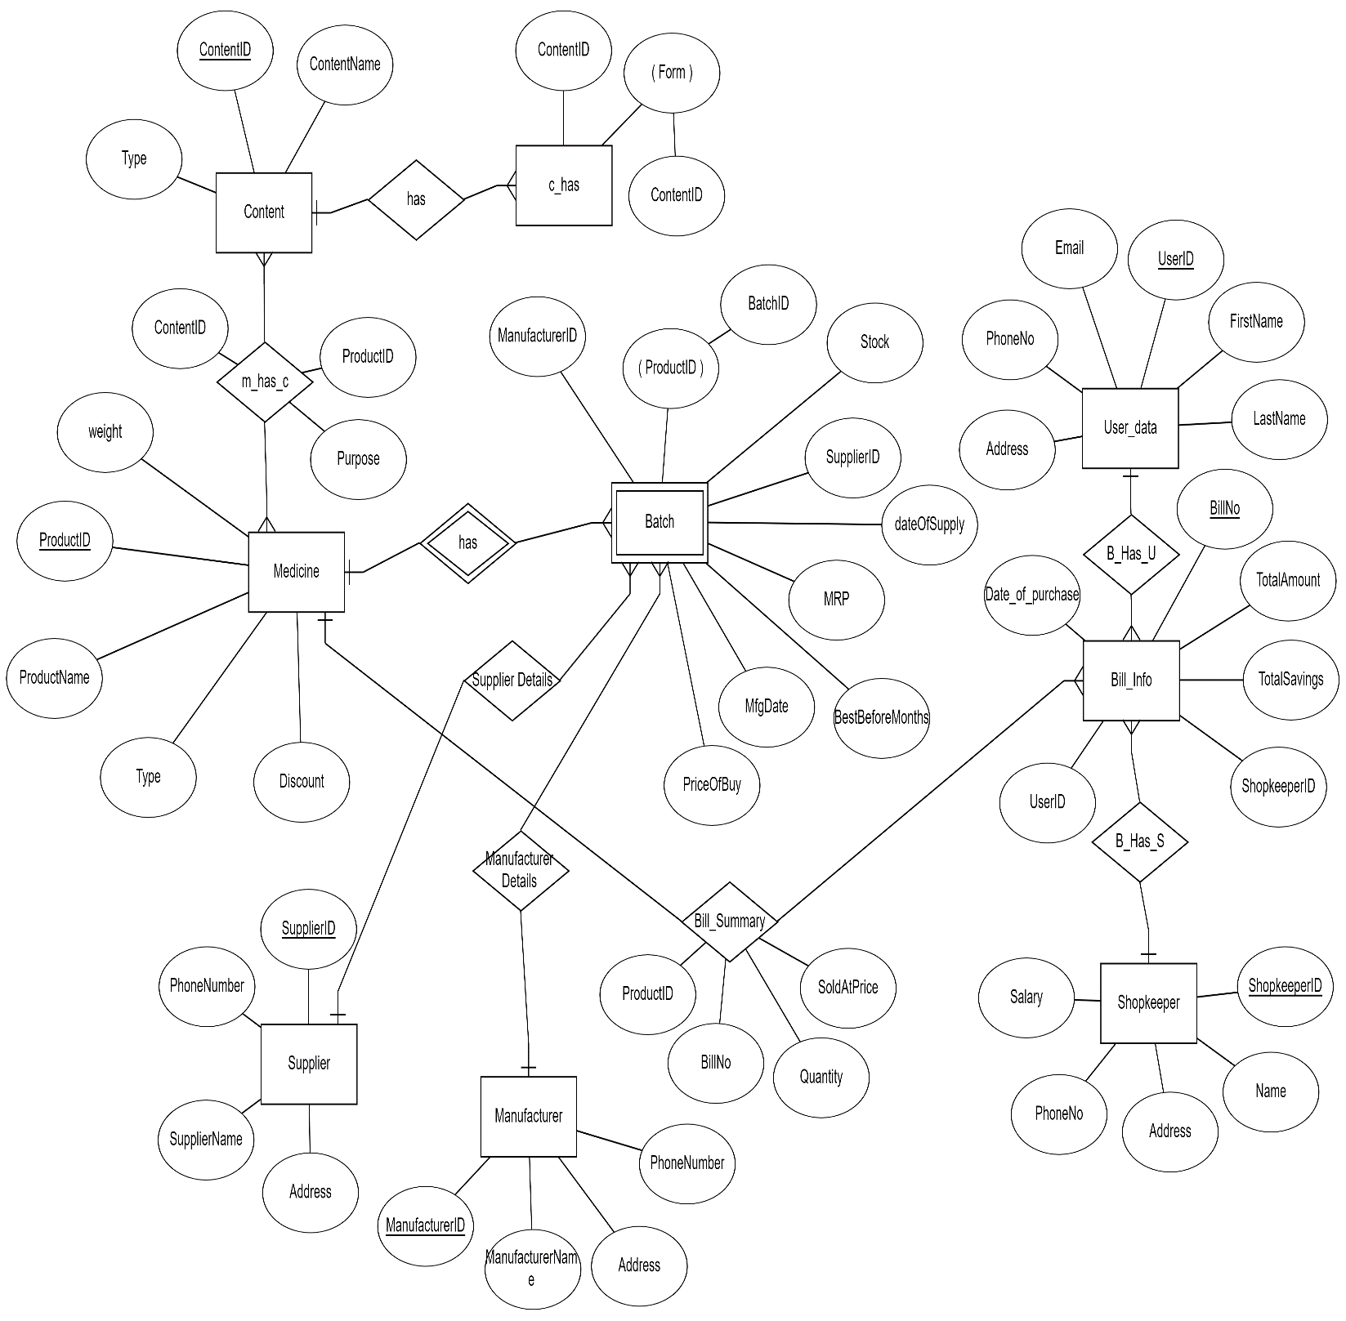

**Data Dictionary**

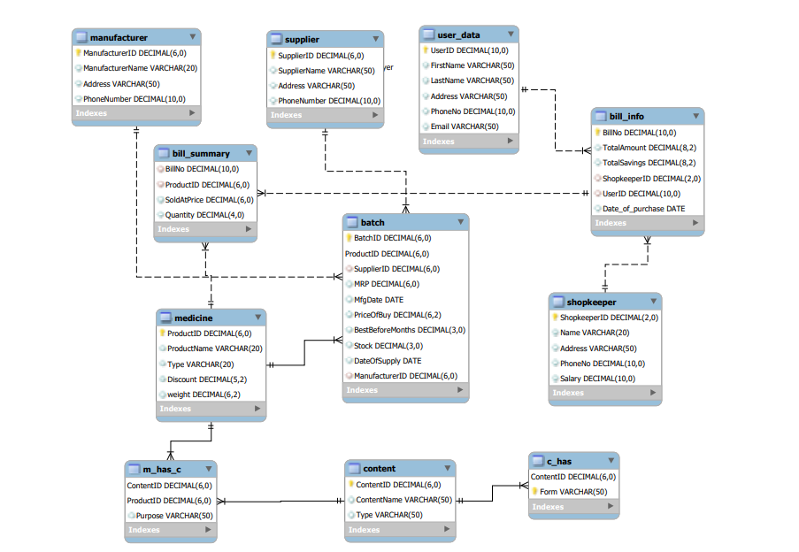

**Procedure/Function 1:**

**This procedure returns Medicine Id, Medicine name and quantity sold, of the top 5 selling medicines of all time.**

**CODE:**

create or replace procedure topSellingMedicine as

cursor c_Bill_Info is select Bill_Summary.ProductID,ProductName,sum(Quantity) Quantity from Bill_Summary join Medicine on Medicine.ProductID=Bill_Summary.ProductID group by Bill_Summary.ProductID,ProductName order by Quantity desc;

r_Bill_Info c_Bill_Info%rowtype;

counter number:=0;

begin

for r_Bill_Info in c_bill_Info loop

DBMS_OUTPUT.PUT_LINE('Product ID : '||r_Bill_Info.ProductID||' Product Name : '||r_Bill_Info.ProductName||' Sold Quantity : '||r_Bill_Info.Quantity);

counter:=counter+1;

if (counter=5) then

exit;

end if;

end loop;

end;

**OUTPUT:**

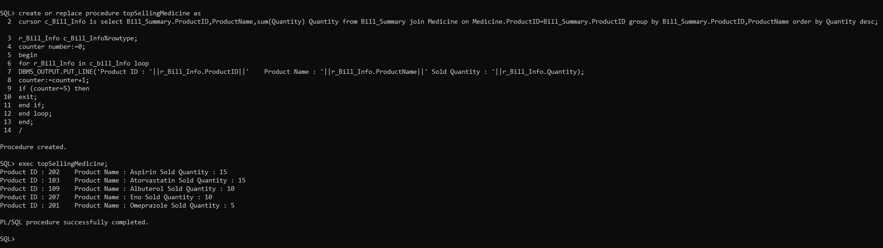

**Procedure/Function 2:**

**This procedure returns the total amount of saving done by all the customers in the current month**.

**CODE:**

create or replace function totalSavingsInThisMonth return number as

savings number;

begin

select sum(TotalSavings) into savings from Bill_Info where to_char(Date_of_purchase,'Month')=to_char(sysdate,'Month') group by to_char(Date_of_purchase,'Month');

return savings;

end;

/

SET SERVEROUTPUT ON;

create or replace procedure savingsInThisMonth

as

saving number;

begin

saving:= totalSavingsInThisMonth();

DBMS_OUTPUT.PUT_LINE('Total Savings Done '||saving||' In This Month : '||to_char(sysdate,'Month'));

end;

**OUTPUT:**

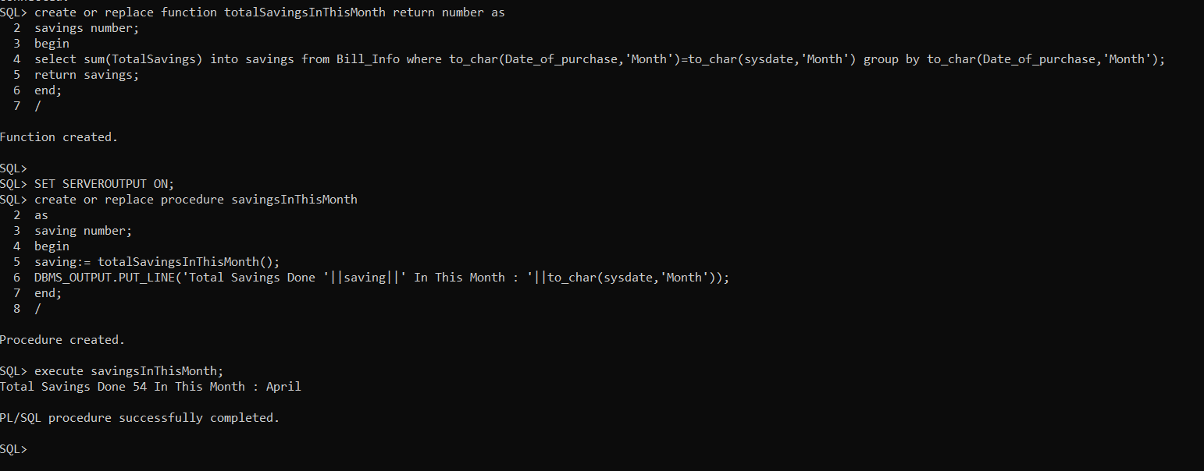

**Procedure/Function 3:**

**This procedure will make insertion easier, just by writing InsertTable_Name(field_values).**

**CODE:**

CREATE OR REPLACE PROCEDURE InsertSupplier (supplier_id IN number,

supplier_name IN varchar,

address IN varchar,

phone_no IN number

)

IS

BEGIN

INSERT INTO Supplier VALUES(supplier_id, supplier_name, address, phone_no);

END;

BEGIN

InsertSupplier(15,'Pharma Medico','Ranip',9111889595);

END;

**OUTPUT:**

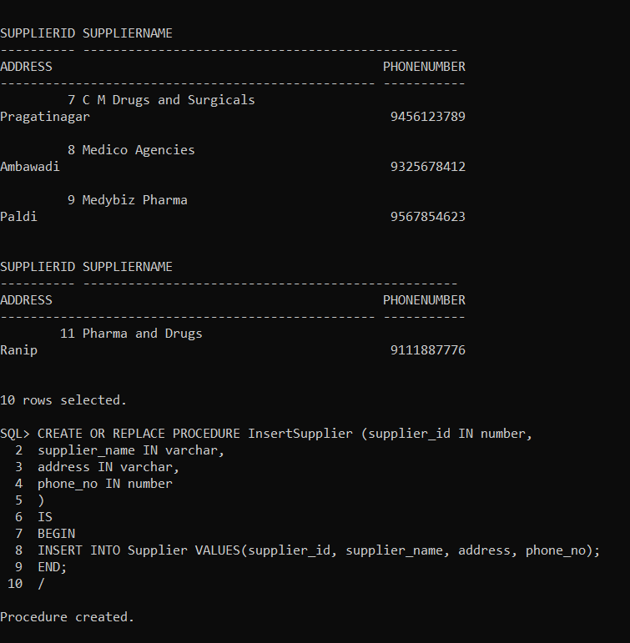

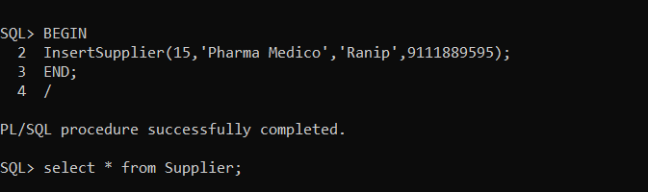

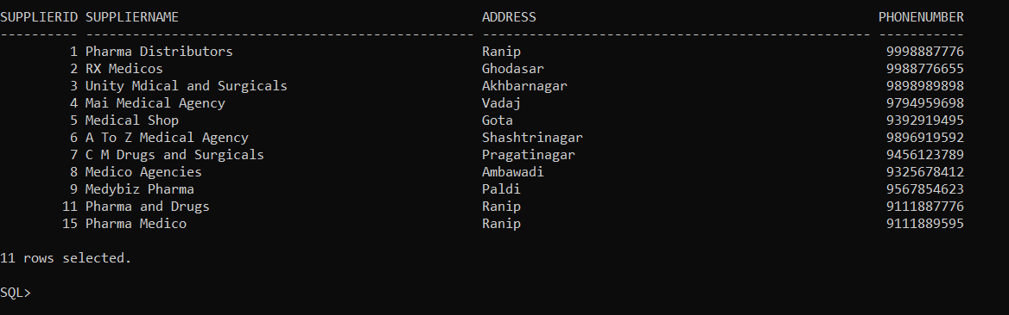

**Procedure/Function 4:**

**This procedure returns the expiry date by inputting ProductID of the required medicine.**

**CODE:**

CREATE OR REPLACE FUNCTION getExpiryDate(p_id number)

RETURN DATE IS

mfg_date date;

expiry_date date;

bbm NUMBER;

BEGIN

SELECT mfgDate INTO mfg_date FROM Batch WHERE ProductID = p_id;

SELECT BestBeforeMonths INTO bbm FROM Batch WHERE ProductID = p_id;

expiry_date:=ADD_MONTHS(mfg_date,bbm);

RETURN expiry_date;

END;

SET SERVEROUTPUT ON;

DECLARE

expiryDate date;

BEGIN

expiryDate:= getExpiryDate(201);

DBMS_OUTPUT.PUT_LINE('Expiry date is ' || expiryDate);

END;

**OUTPUT:**

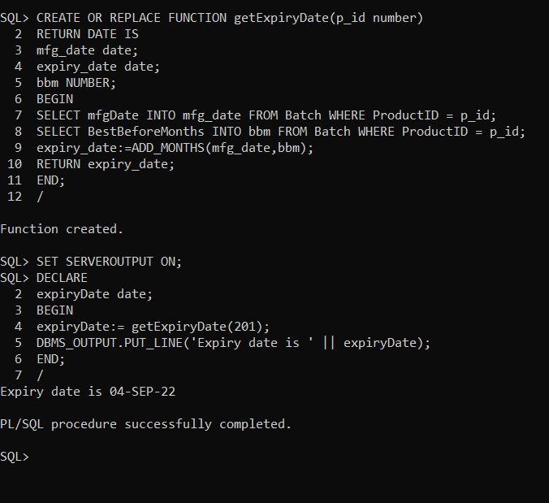

**Procedure/Function 5:**

**This procedure deletes the record of expired medicine from the database automatically, which prevents from getting in Bill_Info, so by chance also a customer can never buy an expired medicine.**

**CODE:**

CREATE OR REPLACE PROCEDURE deletExpiredMedicine

IS

expDate date;

counRows NUMBER;

currentDate date;

cursor c1 is

SELECT *

FROM Batch ;

BEGIN

currentDate:= CURRENT_DATE;

FOR product_details in c1

LOOP

expDate:= getExpiryDate(product_details.ProductID);

IF (expDate <= currentDate)

THEN

DELETE FROM Batch where ProductID = product_details.ProductID;

END IF;

END LOOP;

END;

SET SERVEROUTPUT ON;

BEGIN

deletExpiredMedicine;

END;

**OUTPUT:**

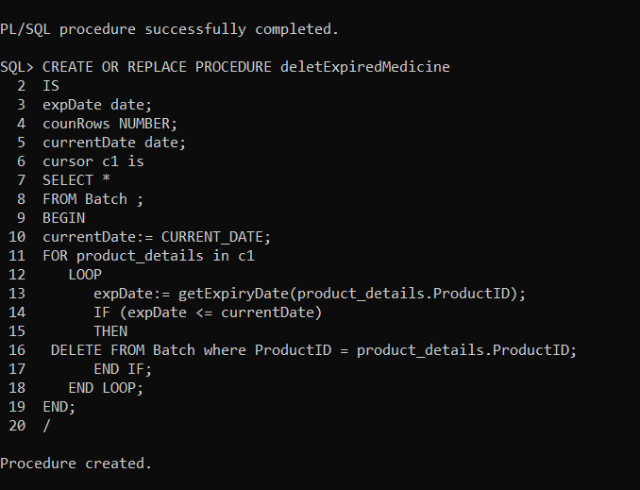

**BEFORE PROCEDURE:**

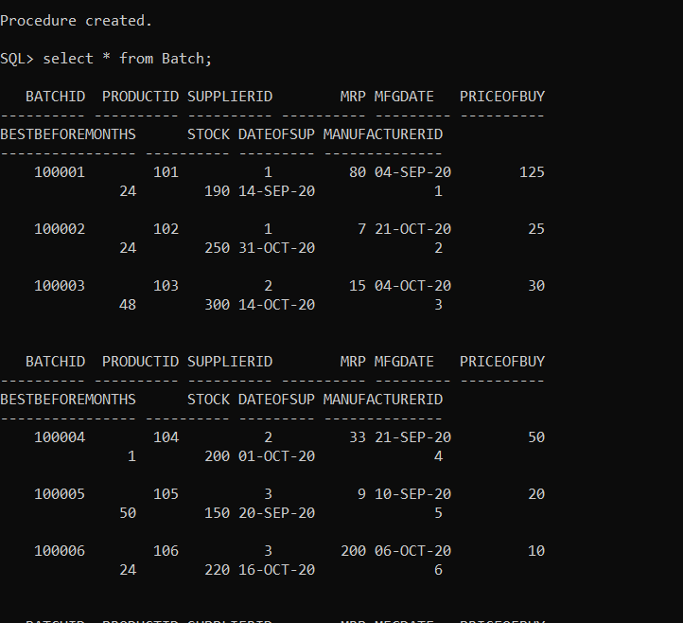

**AFTER PROCEDURE:**

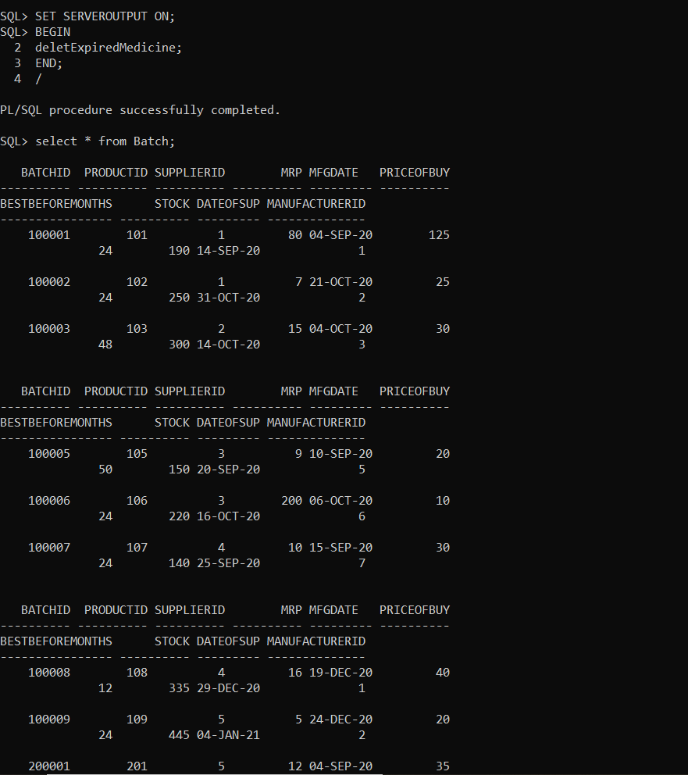

**Procedure/Function 6:**

**This procedure returns the total sells amount produced by all the medicines from the starting of the current month.**

**CODE:**

create or replace function totalSellingInThisMonth return number as

sold number;

begin

select sum(TotalAmount) into sold from Bill_Info where to_char(Date_of_purchase,'Month')=to_char(sysdate,'Month') group by to_char(Date_of_purchase,'Month');

return sold;

end;

/

create or replace procedure sellingsInThisMonth

as

selling number;

begin

selling:= totalSellingInThisMonth();

DBMS_OUTPUT.PUT_LINE('Total Selling Done '||selling||' In This Month : '||to_char(sysdate,'Month'));

end;

**OUTPUT:**

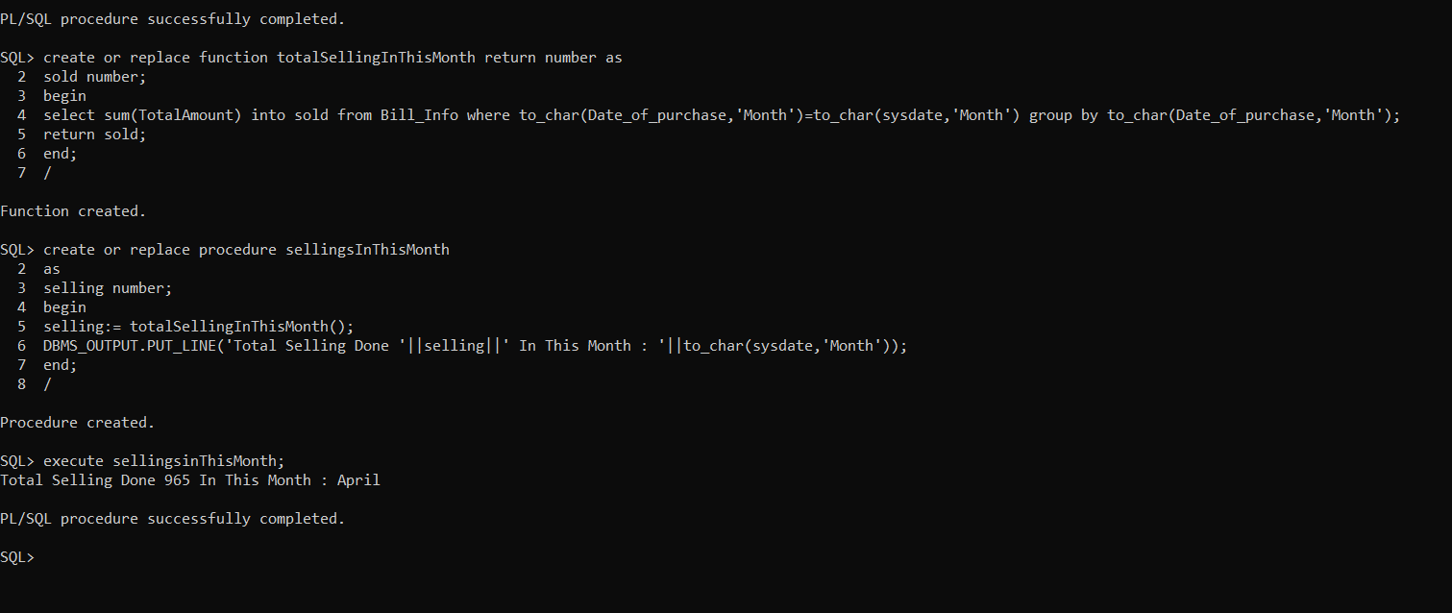

**Procedure/Function 7:**

**This procedure will print Manufacturer Report which includes Manufacturer ID, Manufacturer Name, Address, Phone Number, Quantity available by Manufacturer in Shop.**

**CODE:**

create or replace procedure manufacturerReport as

cursor c_manufacturer is select count(*) c,Batch.ManufacturerID,manufacturername,address,phonenumber from Batch join manufacturer on manufacturer.manufacturerid=batch.manufacturerid group by batch.manufacturerID,manufacturername,address,phonenumber order by c desc;

r_manufacturer c_manufacturer%rowtype;

begin

dbms_output.put_line('Manufacturer Report :');

dbms_output.put_line(rpad('Manufacturer ID',19,' ')||rpad('Manufacturer Name',25,' ')||rpad('Address',15,' ')||rpad('Phone Number',15,' ')||rpad('Quantity Available By Manufacturer in Shop',60,' '));

for r_manufacturer in c_manufacturer loop

dbms_output.put_line(rpad(r_manufacturer.ManufacturerID,19,' ')||''||rpad(r_manufacturer.Manufacturername,25,' ')||''||rpad(r_manufacturer.address,15,' ')||''||rpad(r_manufacturer.phonenumber,15,' ')||''||lpad(r_manufacturer.c,25,' '));

end loop;

end;

/

execute manufacturerReport;

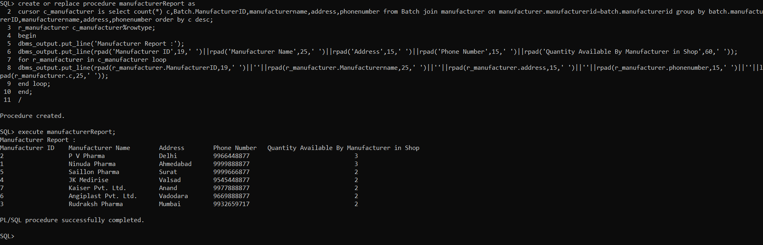

**OUTPUT:**

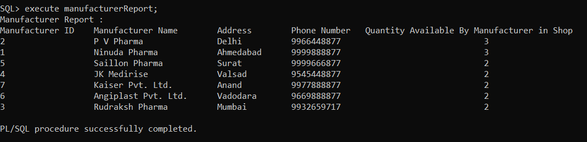

**Procedure/Function 8:**

**This procedure will print Supplier Report which includes Supplier ID, Supplier Name, Address, Phone Number, Supplied Quantity.**

**CODE:**

create or replace procedure supplierReport as

cursor c_supplier is select count(*) c,Batch.SupplierID,suppliername,address,phonenumber from Batch join supplier on supplier.supplierid=batch.supplierid group by batch.SupplierID,suppliername,address,phonenumber order by c desc;

r_supplier c_supplier%rowtype;

begin

dbms_output.put_line('Supplier Report :');

dbms_output.put_line(rpad('Supplier ID',13,' ')||rpad('Supplier Name',30,' ')||rpad('Address',25,' ')||rpad('Phone Number',13,' ')||rpad('Supplied Quantity',18,' '));

for r_supplier in c_supplier loop

dbms_output.put_line(rpad(r_supplier.supplierID,13,' ')||''||rpad(r_supplier.suppliername,30,' ')||''||rpad(r_supplier.address,25,' ')||''||rpad(r_supplier.phonenumber,13,' ')||''||rpad(r_supplier.c,18,' '));

end loop;

end;

/

execute supplierReport

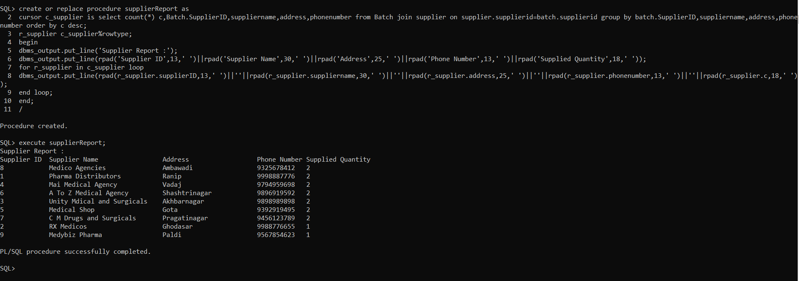

**OUTPUT:**

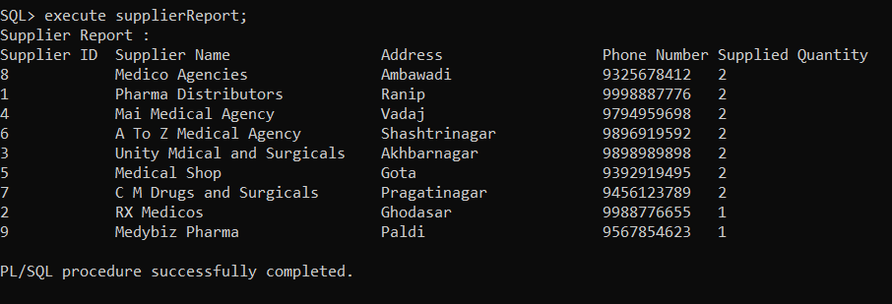

**Procedure/Function 9:**

**This procedure will print Shopkeeper Report which will show user that which shopkeeper done highest selling.**

**CODE:**

create or replace procedure shopkeeperReport as

cursor c_shopkeeperInfo is select bill_info.shopkeeperid,sum(TotalAmount) totalamount,sum(TotalSavings) totalsaving,count(*) BillGenerated,name,salary,address,phoneno from bill_info join shopkeeper on shopkeeper.shopkeeperid=bill_info.shopkeeperid group by salary,name,address,phoneno,bill_info.shopkeeperid order by totalamount desc;

r_shopkeeperInfo c_shopkeeperInfo%rowtype;

begin

dbms_output.put_line('Shopkeeper Report :');

dbms_output.put_line(rpad('ShopkeeperID',13,' ')||rpad('Total selling Done',20,' ')||rpad('Total Saving Provided',25,' ')||rpad('Number of Billgenerated',30,' ')||rpad('Name',20,' ')||rpad('Salary',10,' ')||rpad('Address',20,' ')||rpad('Phone Number',13,' '));

for r_shopkeeperInfo in c_shopkeeperInfo loop

dbms_output.put_line(rpad(r_shopkeeperInfo.ShopkeeperID,13,' ')||''||rpad(r_shopkeeperInfo.totalamount,20,' ')||''||rpad(r_shopkeeperInfo.TotalSaving,25,' ')||''||rpad(r_shopkeeperInfo.Billgenerated,30,' ')||''||rpad(r_shopkeeperInfo.Name,20,' ')||''||rpad(r_shopkeeperInfo.Salary,10,' ')||''||rpad(r_shopkeeperInfo.Address,20,' ')||''||rpad(r_shopkeeperInfo.Phoneno,13,' '));

end loop;

end;

/

execute shopkeeperReport;

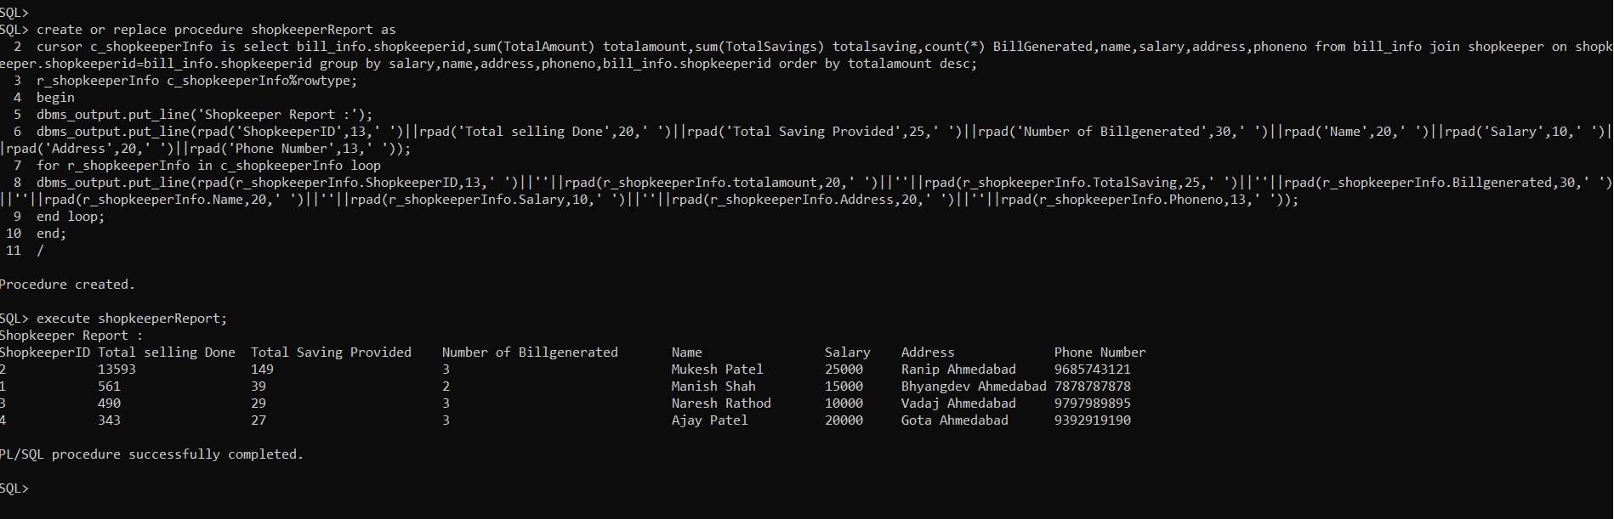

**OUTPUT:**

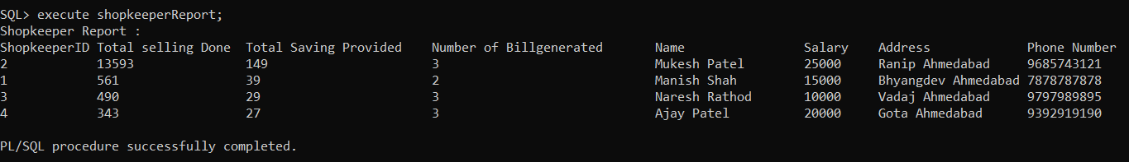

**Procedure/Function 10:**

**This procedure will provide you customer details. User have to just insert Customer ID and it will give purchase detail of that customer.**

**CODE:**

create or replace procedure userPurchaseDetails(UserIDIN number) as

cursor c_userInfo is select Bill_Info.BillNo,TotalAmount,TotalSavings,name,bill_info.UserID,firstname,lastname,Date_of_purchase,bill_summary.productid,medicine.productname,bill_summary.quantity from bill_info join user_data on user_data.userid=bill_info.userid join shopkeeper on shopkeeper.shopkeeperid=bill_info.shopkeeperid join bill_summary on bill_summary.billno=bill_info.billno join medicine on bill_summary.productid=medicine.productid order by date_of_purchase desc;

cursor c_user is select firstname,lastname,userid from user_data;

r_userinfo c_userInfo%rowtype;

r_user c_user%rowtype;

begin

for r_user in c_user loop

if(r_user.userid=UserIDIN) then

dbms_output.put_line('Customer Name: '||r_user.firstname||' '||r_user.lastname);

dbms_output.put_line('User ID: '||r_user.userid);

end if;

end loop;

dbms_output.put_line(rpad('Bill No',8,' ')||rpad('Total Amount',13,' ')||rpad('Total Saving',15,' ')||rpad('ShopkeeperName',25,' ')||rpad('Date of Purchase',25,' ')||rpad('Product ID',15,' ')||rpad('Product Name',15,' ')||rpad('Quantity',10,' '));

for r_userinfo in c_userInfo loop

if(r_userinfo.userid=UserIDIN) then

dbms_output.put_line(rpad(r_userinfo.billno,8,' ')||''||rpad(r_userinfo.totalamount,13,' ')||''||rpad(r_userinfo.totalsavings,15,' ')||''||rpad(r_userinfo.name,25,' ')||''||rpad(r_userinfo.Date_of_Purchase,25,' ')||''||rpad(r_userinfo.ProductID,15,' ')||''||rpad(r_userinfo.ProductName,15,' ')||''||rpad(r_userinfo.Quantity,10,' '));

end if;

end loop;

end;

/

execute userPurchaseDetails(1);

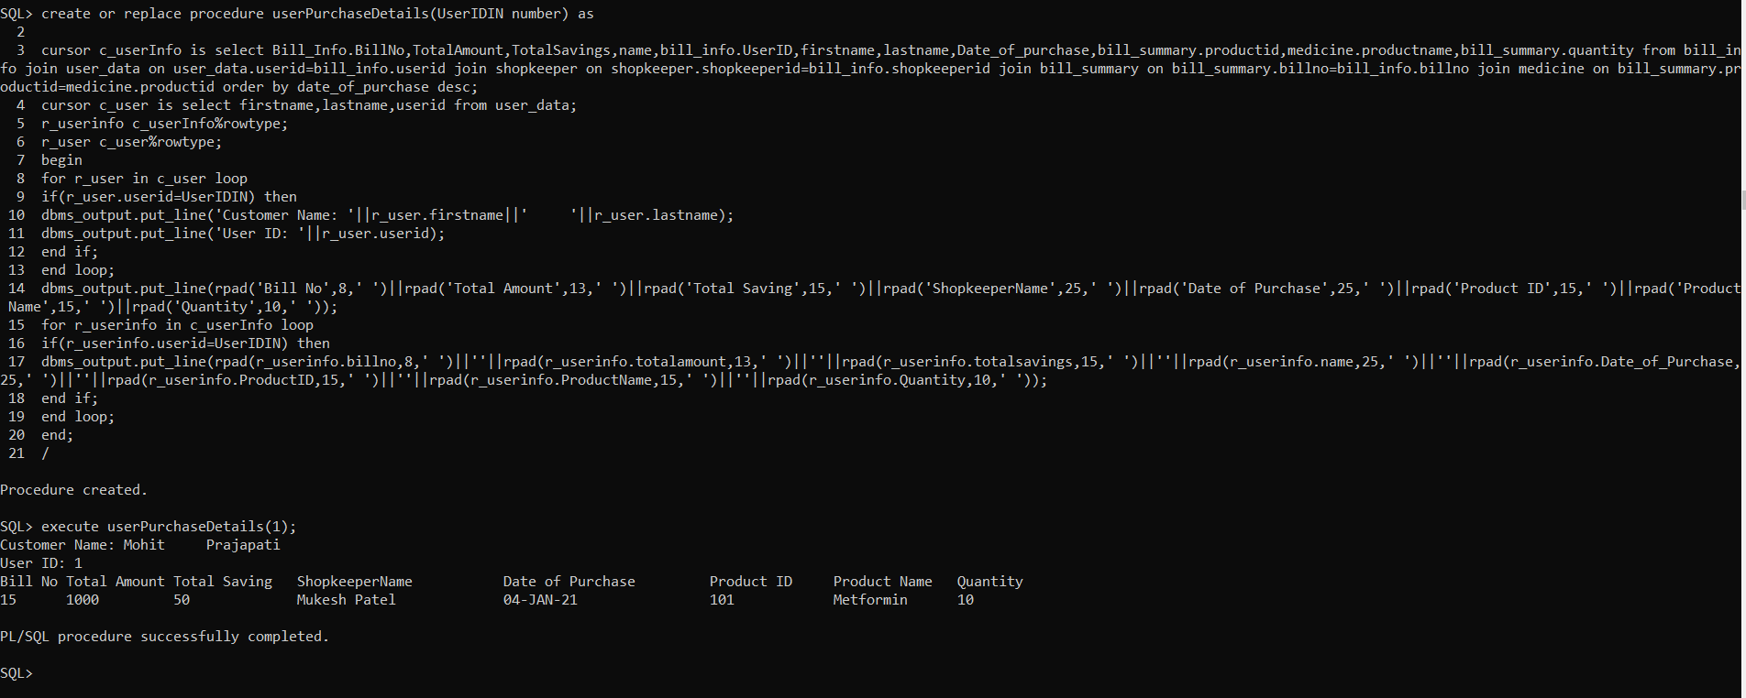

**OUTPUT:**

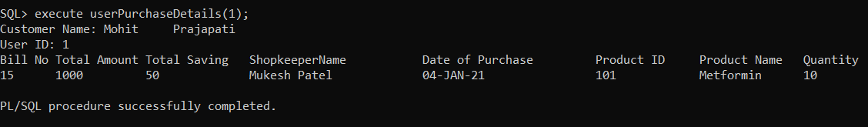

**Trigger 1:**

**This trigger will generate a massage that “You have just inserted a record” when User insert Data.**

**CODE:**

SET SERVEROUTPUT ON;

CREATE OR REPLACE TRIGGER msg_Medicine

BEFORE INSERT ON MEDICINE

FOR EACH ROW

ENABLE

DECLARE

v_user varchar2(20);

BEGIN

SELECT user INTO v_user FROM dual;

DBMS_OUTPUT.PUT_LINE('You Have Just Insrted A Record Mr. '||v_user);

END;

/

insert into Medicine values(501,'Crocin','Tablet',5,50);

**OUTPUT:**

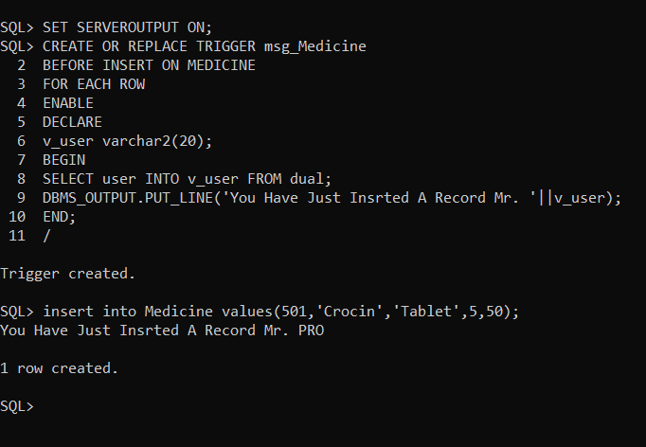

**Trigger 2:**

**This trigger will generate a massage that “You have just updated a record” when User insert Data.**

**CODE:**

SET SERVEROUTPUT ON;

CREATE OR REPLACE TRIGGER msgbu_Medicine

BEFORE UPDATE ON MEDICINE

FOR EACH ROW

ENABLE

DECLARE

v_user varchar2(20);

BEGIN

SELECT user INTO v_user FROM dual;

DBMS_OUTPUT.PUT_LINE('You Have Just Updated A Record Mr. '||v_user);

END;

/

UPDATE Medicine SET ProductName='Tylenol' WHERE ProductName='Crocin';

**OUTPUT:**

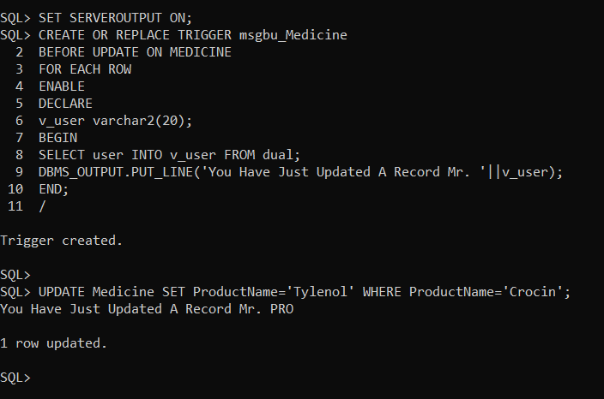

**Trigger 3:**

**This trigger will generate a massage that “You have just updated a record” when User insert Data.**

**CODE:**

SET SERVEROUTPUT ON;

CREATE OR REPLACE TRIGGER msgbd_Medicine

BEFORE DELETE ON MEDICINE

FOR EACH ROW

ENABLE

DECLARE

v_user varchar2(20);

BEGIN

SELECT user INTO v_user FROM dual;

DBMS_OUTPUT.PUT_LINE('You Have Just Deleted A Record Mr. '||v_user);

END;

/

DELETE from Medicine where ProductName='Tylenol';

**OUTPUT:**

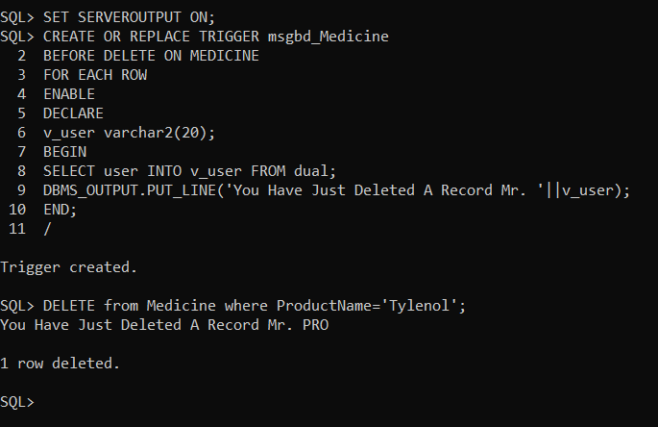

**Trigger 4:**

**This trigger will show error to user that insert different Email ID. User can not duplicate data of Email ID in some other row.**

**CODE:**

create or replace trigger emailValidate

before insert on User_data for each row

declare

vCount NUMBER;

begin

select count(*) into vCount from User_data where Email like :new.Email;

if(vCount > 0) then

raise_application_error(-20100,'Email ID Already Exist Please Try Different Email ID.');

end if;

end;

insert into User_data values(12,'Mohit','Shah','Ahmedabad',9656982323,'mp@gmail.com');

**OUTPUT:**

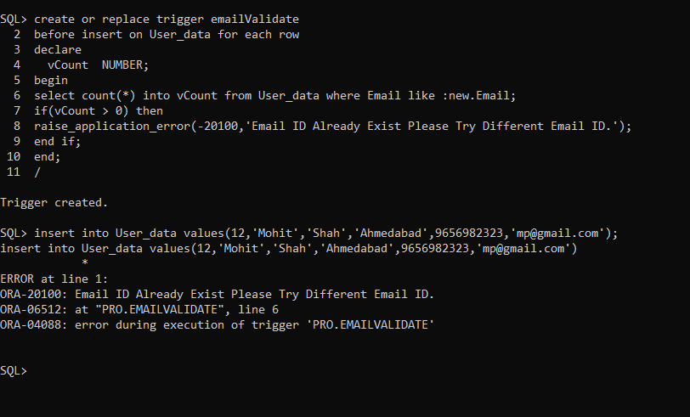

**Trigger 5:**

**This trigger will show error to user that insert different Phone Number. User cannot duplicate data of Phone Number in some other row.**

**CODE:**

create or replace trigger phoneNumberValidate

before insert on Supplier for each row

declare

vCount NUMBER;

begin

select count(*) into vCount from Supplier where PhoneNumber like :new.PhoneNumber;

if(vCount > 0) then

raise_application_error(-20101,'Phone Number Already Exist Please Try Different Phone Number.');

end if;

end;

insert into Supplier values(19,'Medico Pharma','Kalol',9567854623);

**OUTPUT:**

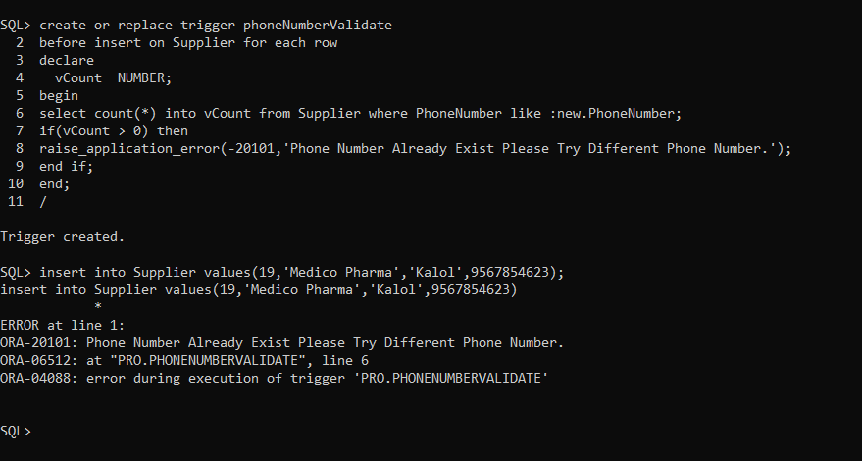

**Trigger 6:**

**This trigger will update stock of medicine when new bill is generated.**

**CODE:**

create or replace trigger updateQty

after insert on Bill_Summary for each row

declare

Qty NUMBER;

begin

select Stock into Qty from Batch where ProductID=:new.ProductID;

update Batch SET Stock=Qty-:new.Quantity where ProductID=:new.ProductID;

end;

insert into Bill_Info values(15,1000,50,2,1,'04-JAN-2021');

insert into Bill_Summary values(15,101,125,10);

**OUTPUT:**

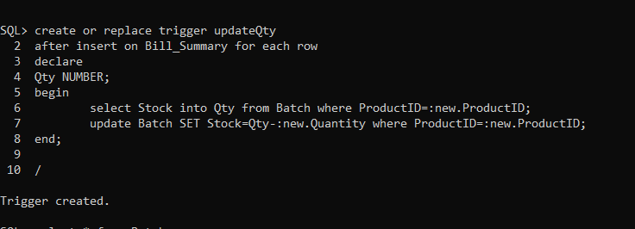

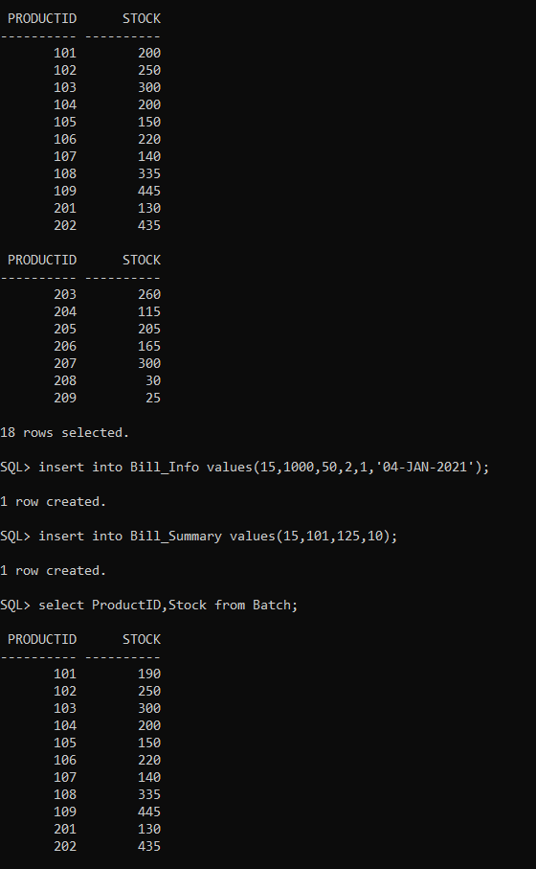

**Trigger 7:**

**This trigger will show error if quantity of order placed is higher than stock. It will show error that “Excessive Quantity Order.”.**

**CODE:**

create or replace trigger checkQty

before insert on Bill_Summary for each row

declare

Qty NUMBER;

begin

select Stock into Qty from Batch where ProductID=:new.ProductID;

if Qty<:new.Quantity then

delete from Bill_Info where BillNo=:new.BillNo;

raise_application_error(-20200,'Excessive Quantity Order.');

end if;

end;

insert into Bill_Info values(16,1000,50,2,1,'04-JAN-2021');

insert into Bill_Summary values(16,101,125,200);

**OUTPUT:**

